Controller Microarchitecture

High-Level Overview
The Controller is the instruction decoder and multi-cycle sequencer for the PE. It receives a 5-bit instruction from the top-level module, decodes the requested operation, and asserts the control signals that drive the MAC & SCALE, the Post-Processing Unit (PPU), and the I/O Block. It also contains the configuration register.
The Controller is organized into three functional blocks: Instruction Capture, Instruction Decoder, and SCALE Sequencer.

Interface
Input Ports
Port Name | Direction | Width | Description
clk | Input | 1 bit | Main system clock. All internal registers capture on the rising edge.
rst | Input | 1 bit | Active-low asynchronous reset. Clears all internal state registers and outputs to a known value.
pe_opcode | Input | 5-bit bus | The main instruction fed into the PE from the top-level inputs. Sampled into an internal opcode register subject to the gating conditions described in the Instruction Capture section.
chp_slct | Input | 1 bit | Chip select. When low, the Controller ignores all incoming opcodes. Multi-cycle operations already in progress continue to completion.
opcode_valid | Input | 1 bit | Opcode input validity qualifier. Asserted by the external system to indicate that the current cycle's opcode is valid and should be sampled.
cfg_data_in | Input | 4-bit bus | Configuration register load data, sourced from operand_A_reg[3:0] at the I/O Block. Captured into the configuration register when LOAD_CFG is decoded.
Table 1. Input port interface.

Output Ports — MAC & SCALE Datapath Control
Port Name | Direction | Width | Description
mode4x4 | Output | 1 bit | Multiplier mode select. Cycle-resolved: equals 0 during SCALE cycles (forcing 8×8 multiplier operation); equals ~config_reg[3] otherwise. Routed to both the MAC & SCALE and the PPU.
a_is_signed | Output | 1 bit | Sign control for all A-operand bytes entering the multiplier array.
b_is_signed | Output | 1 bit | Sign control for all B-operand bytes entering the multiplier array.
scale_mode | Output | 1 bit | Datapath select: 0 — MAC; 1 — SCALE.
latch_en * | Output | 1 bit | Enables capture of the current accumulator into the MAC & SCALE holding register.
scale_phase | Output | 2-bit bus | SCALE cycle index.
mac4_en | Output | 1 bit | INT4 MAC path isolation. 0 — inputs forced to zero; 1 — path active.
mac8_en | Output | 1 bit | INT8 MAC path isolation. 0 — inputs forced to zero; 1 — path active.
acc_source | Output | 2-bit bus | Accumulator input source select. 0 — INT4 MAC result; 1 — INT8 MAC result; 2 — SCALE partial product; 3 — bias.
acc_wr_en | Output | 1 bit | Enables the accumulator register to capture a new value on the next rising clock edge.
acc_load * | Output | 1 bit | 0 — accumulate into the accumulator; 1 — overwrite the accumulator with SCALE's cycle 0 addend.
rst_acc | Output | 1 bit | Synchronous clear of the accumulator to zero on the next rising clock edge.
Table 2. MAC & SCALE datapath control port interface.

Output Ports — PPU
Port Name | Direction | Width | Description
ppu_en | Output | 1 bit | One-cycle pulse when EXEC_PP is decoded. Gates the PPU's activation path input and serves as a select line for the I/O output multiplexer and as a write qualifier for the I/O output register.
shamt_wr_en * | Output | 1 bit | Shift-amount register write enable. Enables the PPU's shift-amount register to capture its data on the next rising edge when SCALE is decoded.
act_fn_sel | Output | 3-bit bus | Activation function select. Equals config_reg[2:0]. Routed to the PPU. Stable between LOAD_CFG instructions.
Table 3. PPU port interface.
* latch_en, shamt_wr_en, and acc_load are driven by the same physical Controller output. They are listed as separate output ports to distinguish their functional roles within the MAC & SCALE and the PPU.

Output Ports — Output Path and Top-Level
Port Name | Direction | Width | Description
read_acc_en | Output | 1 bit | One-cycle pulse when READ_ACC_BYTE is decoded. Serves as a select line for the I/O output multiplexer and as a write qualifier for the I/O output register.
read_cfg_en | Output | 1 bit | One-cycle pulse when READ_CFG is decoded. Serves as a select line for the top-level output multiplexer and as a write qualifier for the I/O output register.
config_out | Output | 4-bit bus | Configuration register value. Continuously driven from config_reg[3:0]. Routed to the I/O output multiplexer.
pe_ready | Output | 1 bit | Flow-control flag driven to the external interface and also consumed by the I/O Block. High when the PE is ready to accept a new instruction; low during SCALE operation. Gates operand and opcode register captures across the I/O Block and the Controller.
output_valid | Output | 1 bit | Pulsed high for one clock cycle, one clock period after any output-producing instruction (EXEC_PP, READ_ACC_BYTE, or READ_CFG), to indicate that the final result is stable on the PE's output bus.
Table 4. Output path and top-level port interface.

For the remainder of this document, the shared physical output driving latch_en, shamt_wr_en, and acc_load is referred to uniformly as latch_en. The individual names appear only in Tables 2–3 and in top-level connectivity.

Instruction Capture
The Instruction Capture block captures the incoming opcode, validates it, and holds the PE configuration register. It produces two outputs consumed by the rest of the Controller: the validated command that feeds the Instruction Decoder and the SCALE Sequencer, and the configuration register contents that feed the Instruction Decoder and other PE modules.
Opcode Register and Gating
The block contains a 5-bit opcode register. On each rising clock edge, the register captures pe_opcode if pe_ready, opcode_valid, and chp_slct are all high. If any condition is not met, the register is loaded with NOP. On asynchronous reset, the opcode register is cleared to NOP.
Opcode Validator
The validator recognizes nine operations: NOP, RST_ACC, MAC, ADD_BIAS, SCALE, LOAD_CFG, EXEC_PP, READ_ACC_BYTE, and READ_CFG. All other encodings are mapped to NOP. The validated command drives the Instruction Decoder.
Configuration Register
The Controller contains a 4-bit configuration register loaded on the next rising clock edge after a valid LOAD_CFG instruction by cfg_data_in[3:0]. On asynchronous reset, the register clears to 4'b0000 (INT4 mode and Identity activation function).
Bit [3] is the precision mode: 0 selects INT4, 1 selects INT8. Bits [2:0] select the activation function. The encoding table is defined in the PE Definition Document.
Two continuously driven outputs are derived from the register. act_fn_sel equals config_reg[2:0] and is routed to the PPU. config_out equals config_reg[3:0] and is routed to the I/O output multiplexer. A third signal, mode4x4, is also derived from config_reg[3] but is cycle-resolved in the Instruction Decoder; see the Multiplier Configuration section.
The precision mode also influences the Instruction Decoder: it determines the acc_source and isolation-enable signals during MAC.

Instruction Decode
The Instruction Decoder is the core signal-production block. It reads the validated command from the Instruction Capture block, the current FSM state from the SCALE Sequencer, the precision mode from the configuration register, and produces all control signals as combinational outputs.
The signal values are determined by two sources.
When the FSM is in IDLE, the signal values are determined by the validated command and, for MAC, also by config_reg[3]; this covers all single-cycle operations as well as the first SCALE execution cycle (where the validated command is SCALE and the FSM has not yet transitioned out of the IDLE state).
When the FSM is in any SCALE state (SC1, SC2, or SC3), the FSM state takes priority and the signal values follow the per-cycle table in the SCALE Sequencer section.
Signals marked as don't-care (x) in the truth tables below have no functional effect on the datapath for that command, because they are gated off by other control signals (such as isolation enables or write enables). The RTL implementation drives all don't-care signals to zero as a default assignment to prevent unnecessary toggling.
Multiplier Configuration
mode4x4 is forced low during all four SCALE execution cycles to guarantee 8×8 multiplier operation. Outside of SCALE cycles, mode4x4 equals ~config_reg[3].
a_is_signed is high for MAC. During the SCALE sequence, it is low on execution cycles 0 through 2 and high on execution cycle 3. For all other commands it is don't-care.
b_is_signed is high for MAC, and low during all SCALE states. For all other commands it is don't-care.

Input Routing
scale_mode is high during all four SCALE states and low otherwise.
scale_phase is 00 on execution cycle 0, 01 on cycle 1, 10 on cycle 2, and 11 on cycle 3. During non-SCALE cycles, scale_phase is don't-care.
latch_en is high only on execution cycle 0, and low on all other cycles and commands.
Path Isolation
Exactly one isolation enable is high during any active computation. For MAC, mac4_en is high when in INT4 mode (config_reg[3] is low) and mac8_en is high when in INT8 mode (config_reg[3] is high). Both are low during all four SCALE execution cycles and for all other commands.
The SCALE stitching tree inside the MAC & SCALE receives its isolation enable from the same scale_mode signal.
Accumulator Control
acc_source selects the addend path into the Accumulation Unit. During MAC, the value depends on the precision mode: 2'b00 (INT4 MAC result) when in INT4 mode, 2'b01 (INT8 MAC result) when in INT8 mode. During all four SCALE execution cycles, acc_source is 2'b10. For ADD_BIAS, acc_source is 2'b11. For all other commands the value is don't-care.
acc_wr_en is high for MAC, ADD_BIAS, and during all four SCALE execution cycles. It is low for all other commands.
rst_acc is high only for RST_ACC, and low for all other commands.
PPU and Output Control
ppu_en is high for EXEC_PP, and low for all other commands.
read_acc_en is high for READ_ACC_BYTE, and low for all other commands.
read_cfg_en is high for READ_CFG, and low for all other commands.

Single-Cycle Command and SCALE First Cycle Truth Table
Table 5 lists the signal values for every decoded command in a single place. NOP and LOAD_CFG share a column because their output vectors are identical; LOAD_CFG's effect is internal (see Configuration Register). Shorthand: cfg[3] ≡ config_reg[3]; x ≡ don't-care, driven to 0 by default.
Signal / Command | NOP / LOAD_CFG | RST_ACC | MAC | ADD_BIAS | SCALE (cycle 0) | EXEC_PP | READ_ACC_BYTE | READ_CFG
mode4x4 | ~cfg[3] | ~cfg[3] | ~cfg[3] | ~cfg[3] | 0 | ~cfg[3] | ~cfg[3] | ~cfg[3]
a_is_signed | x | x | 1 | x | 0 | x | x | x
b_is_signed | x | x | 1 | x | 0 | x | x | x
scale_mode | 0 | 0 | 0 | 0 | 1 | 0 | 0 | 0
scale_phase | xx | xx | xx | xx | 00 | xx | xx | xx
latch_en | 0 | 0 | 0 | 0 | 1 | 0 | 0 | 0
mac4_en | 0 | 0 | ~cfg[3] | 0 | 0 | 0 | 0 | 0
mac8_en | 0 | 0 | cfg[3] | 0 | 0 | 0 | 0 | 0
acc_source | xx | xx | {0, cfg[3]} | 11 | 10 | xx | xx | xx
acc_wr_en | 0 | 0 | 1 | 1 | 1 | 0 | 0 | 0
rst_acc | 0 | 1 | 0 | 0 | 0 | 0 | 0 | 0
ppu_en | 0 | 0 | 0 | 0 | 0 | 1 | 0 | 0
read_acc_en | 0 | 0 | 0 | 0 | 0 | 0 | 1 | 0
read_cfg_en | 0 | 0 | 0 | 0 | 0 | 0 | 0 | 1
Table 5. Single-cycle and SCALE cycle 0 signal values.

SCALE Sequencer
The SCALE Sequencer contains the finite state machine that governs the multi-cycle scaling operation and the post-completion signaling to the top-level interface.
FSM States and Transitions
The FSM has four states: IDLE, SC1, SC2, and SC3.
IDLE is the default state. The Controller accepts and decodes incoming opcodes. When the validated command is SCALE and the FSM is in IDLE, the Instruction Decoder drives the first SCALE execution cycle signals directly. The FSM transitions to SC1 on the next clock edge.
SC1, SC2, and SC3 drive execution cycles 1, 2, and 3 respectively. The transitions are unconditional and linear: SC1 to SC2, SC2 to SC3, and SC3 back to IDLE.
On asynchronous reset, the FSM is forced to IDLE.

SCALE FSM Cycle Signal Values
The following table lists the signal values driven during FSM states SC1, SC2, and SC3, corresponding to SCALE execution cycles 1, 2, and 3. Execution cycle 0 is listed in Table 5.
Signal / State | SC1 | SC2 | SC3
mode4x4 | 0 | 0 | 0
a_is_signed | 0 | 0 | 1
b_is_signed | 0 | 0 | 0
scale_mode | 1 | 1 | 1
scale_phase | 01 | 10 | 11
latch_en | 0 | 0 | 0
mac4_en | 0 | 0 | 0
mac8_en | 0 | 0 | 0
acc_source | 10 | 10 | 10
acc_wr_en | 1 | 1 | 1
rst_acc | 0 | 0 | 0
shamt_wr_en | 0 | 0 | 0
ppu_en | 0 | 0 | 0
read_acc_en | 0 | 0 | 0
read_cfg_en | 0 | 0 | 0
Table 6. SCALE FSM cycle signal values (SC1–SC3).

pe_ready
pe_ready drops on the same cycle that SCALE is decoded, even before the FSM transitions out of IDLE, and rises immediately when the FSM returns to IDLE after SC3.
output_valid
output_valid is asserted for one-cycle pulse one clock cycle after any of EXEC_PP, READ_ACC_BYTE, or READ_CFG is decoded.

SCALE End-to-End Timing
Below is a SCALE end-to-end timing diagram.
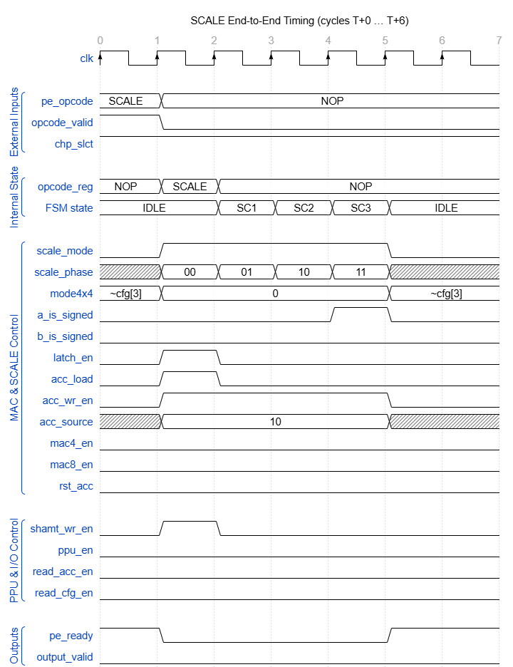
Figure 2. SCALE cycle-accurate timing diagram.

Diagram explanation: The external system presents the SCALE opcode on pe_opcode with opcode_valid and chp_slct high between clock edges 0 and 1. At edge 1, the opcode register captures SCALE. The Opcode Validator passes it through as a valid command, and the Instruction Decoder drives the first execution cycle (cycle 0) control signals while the FSM remains in IDLE. At edge 2, the MAC & SCALE captures the first partial product, the FSM transitions to SC1, and the opcode register reverts to NOP since pe_ready is low. Execution cycles 1 through 3 proceed unconditionally through SC1, SC2, and SC3 on edges 3, 4, and 5 respectively. At edge 5, the FSM returns to IDLE and pe_ready rises.

Asynchronous Reset Behavior
When rst is driven low, all internal states are immediately cleared to a known state regardless of the clock. The FSM is forced to IDLE, the opcode register is cleared to NOP, the configuration register is cleared to 4'b0000, and the output_valid flip-flop is cleared to zero. With the exception of pe_ready (which is combinationally gated by rst directly so that it drops immediately on reset assertion and rises immediately on release), all Controller outputs are purely combinational functions of opcode_reg, config_reg, and the FSM state. Because the decoder has no direct dependence on any external input, clearing these three registers fully determines the output vector: all outputs propagate to the values listed in the NOP / LOAD_CFG column of Table 5, with mode4x4 = 1, act_fn_sel = 3'b000, and config_out = 4'b0000 reflecting the 4'b0000 configuration reset value.

